**LAB Cycle sheet – 1**

**Internet and Web Programming**

**CSE3002**

**L55+L56**

**19BCE2141**

**Q1.**

**Code –**

<!DOCTYPE html>

<html lang="en">

<head>

<meta charset="UTF-8">

<meta http-equiv="X-UA-Compatible" content="IE=edge">

<meta name="viewport" content="width=device-width, initial-scale=1.0">

<title>Q1</title>

</head>

<body style="padding: 10px; background-color: yellow;">

<marquee behavior="slide" direction="up">

<h3 style="text-align: center; color: green;">

<i>Grihit Budhiraja</i>

</h3>

</marquee>

<h3 style="text-align: center; color: green;">

<i>19BCE2141</i>

</h3>

<span style="color: red;">1</span>

<span style="color: blue;">2</span>

<span style="color: purple;">3</span>

<span style="color: maroon;">4</span>

<span style="color: gray;">5</span>

<span style="color: brown;">6</span>

<span style="color: orange;">7</span>

<span style="color: black;">8</span>

<span style="color: darkkhaki;">9</span>

<span style="color: darkgreen;">10</span>

<br><br>

<span style="font-family: 'Courier New', Courier, monospace;">Lorem ipsum dolor sit amet, consectetur adipiscing elit.</span>

<span style="font-family: 'Franklin Gothic Medium', 'Arial Narrow', Arial, sans-serif;">Mauris id euismod diam.</span>

<span style="font-family: 'Lucida Sans', 'Lucida Sans Regular', 'Lucida Grande', 'Lucida Sans Unicode', Geneva, Verdana, sans-serif;">Aliquam eu sem est.</span>

<span style="font-family: 'Trebuchet MS', 'Lucida Sans Unicode', 'Lucida Grande', 'Lucida Sans', Arial, sans-serif;">Proin ultrices, neque ut aliquet condimentum, augue ipsum condimentum erat, sit amet porttitor turpis elit nec massa.</span>

<span style="font-family: Impact, Haettenschweiler, 'Arial Narrow Bold', sans-serif;">Donec at aliquam tortor. Vestibulum ut sem sagittis, eleifend ligula ac, vestibulum nisi.</span><br><br>

<h2 style="text-align: center; margin-bottom: 12px;">The Kite Runner</h2>

<h4 style="text-align: center; margin-top: 0px;">&nbsp;&nbsp;&nbsp;&nbsp;&nbsp;&nbsp;&nbsp;&nbsp;&nbsp;&nbsp;&nbsp;&nbsp;&nbsp;&nbsp;&nbsp;&nbsp;&nbsp;&nbsp;&nbsp;&nbsp; - Khaled Hosseini</h4>

<p>

<u>The Kite Runner</u> is the first novel by Afghan-American author </u>Khaled Hosseini.</u> Published in 2003 by <u>Riverhead Books</u>, it tells the story of <u>Amir</u>, a young boy from the <u>Wazir Akbar Khan</u> district of <u>Kabul</u>. The story is set against a backdrop of <b><i>tumultuous</i></b> events, from the fall of Afghanistan's monarchy through the <u>Soviet military intervention</u>, the exodus of refugees to <u>Pakistan</u> and the <u>United States</u>, and the rise of the <u>Taliban regime</u>.

<br><br>

<u>Hosseini</u> has commented that he considers <u>The Kite Runner</u> to be a father-son relationship story, emphasizing the familial aspects of the narrative, an element that he continued to use in his later works. Themes of <b><i>guilt</i></b> and <b><i>redemption</i></b> feature prominently in the novel, with a pivotal scene depicting an act of sexual assault that happens against <u>Hassan</u> that <u>Amir</u> fails to prevent. The situation as a whole was the main reason why Amir and Hassan's friendship ended. The latter half of the book centers on Amir's attempts to atone for this transgression by rescuing Hassan's son two decades later.

</p>

<h1>Grihit Budhiraja</h1>

<h2>Grihit Budhiraja</h2>

<h3>Grihit Budhiraja</h3>

<h4>Grihit Budhiraja</h4>

<h5>Grihit Budhiraja</h5>

<h6>Grihit Budhiraja</h6>

<!-- This is a comment and will not be displayed in the page-->

<h2>C code</h2>

<pre>

<code>

#include "stdio.h"

int main() {

int a,b,sum;

printf("Enter the two numebers");

scanf("%d %d" , &a,&b);

sum=a+b;

printf("%d + %d = %d", &a, &b, &sum);

return 0;

}

</code>

</pre>

</body>

</html>

**Output –**

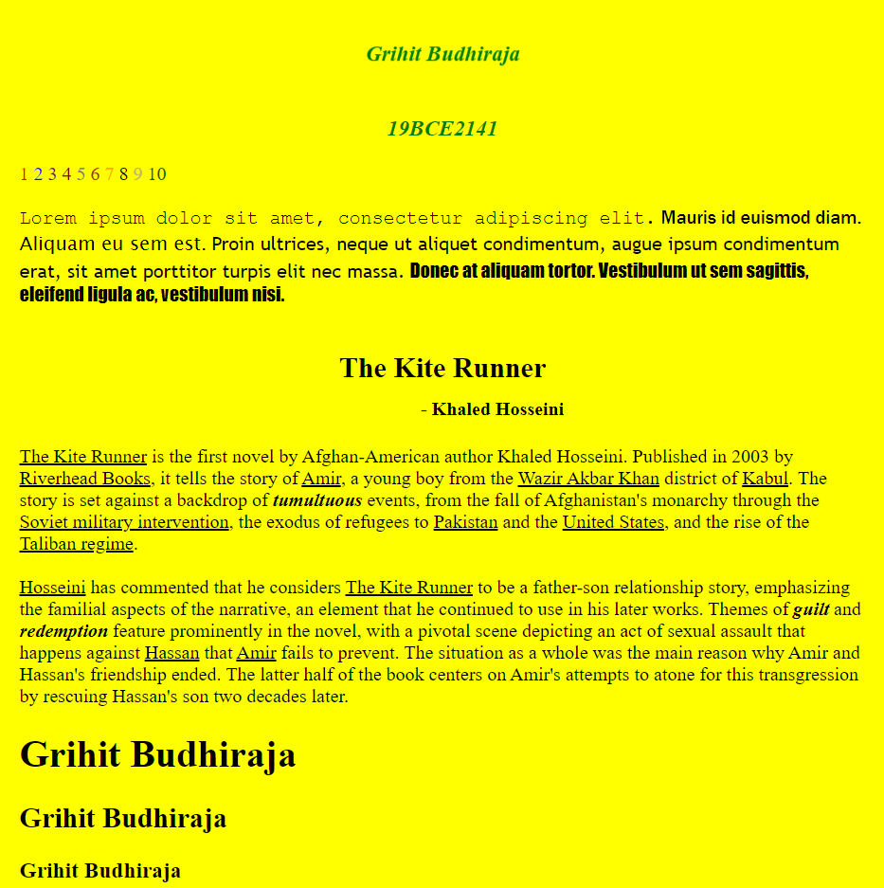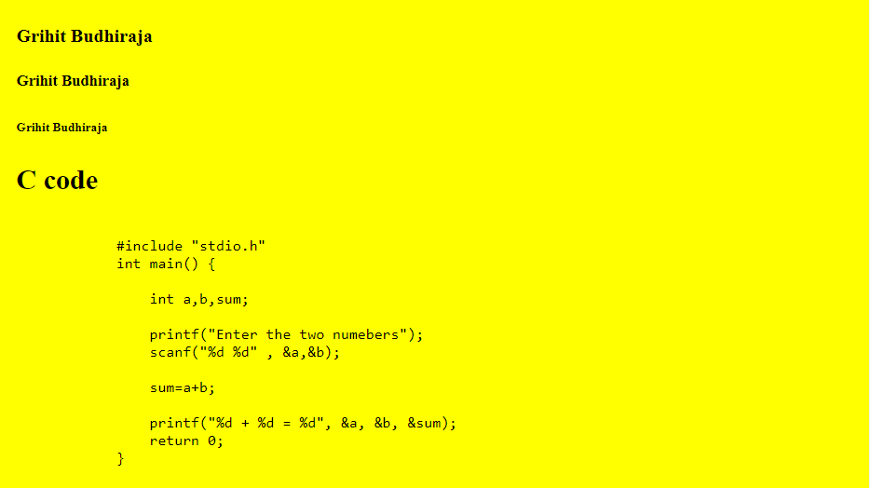

**Q2**

**Code –**

<!DOCTYPE html>

<html lang="en">

<head>

<meta charset="UTF-8">

<meta http-equiv="X-UA-Compatible" content="IE=edge">

<meta name="viewport" content="width=device-width, initial-scale=1.0">

<title>About Me</title>

<link rel="stylesheet" href="./q1.css">

</head>

<body style="text-align: center; font-family: Arial, Helvetica">

<h2>Grihit Budhiraja</h2>

<h3>SU 203, Pitampura, Delhi </h3>

<p>I am a 2nd year Btech CSE student in VIT Vellore. I am from Delhi. I am interested <br> in <em><b>Competitive coding</b></em> and also like to play <em><b>football</b></em> in my spare time</p>

<table border="2" style="margin-left:auto;margin-right:auto;background-color: rgb(255, 225, 188);" >

<th style="padding:10px; color: blue;"><h3>Classes I am taking this semester</h3></th>

<th style="padding:10px;color: blue;"><h3>Description of each class</h3></th>

<tr>

<td style="color: cornflowerblue;">Internet and Web Programming</td>

<td style="color: rgb(255, 9, 9);">Information about detailed web programming and <br> various technologies used for making websites and web apps</td>

</tr>

<tr>

<td style="color: cornflowerblue;">Java programming</td>

<td style="color: rgb(255, 9, 9);" >Information about detailed Java programming and <br> various algorithms used for making java applications and java apps</td>

</tr>

<tr>

<td style="color: cornflowerblue;">Software Engineering</td>

<td style="color: rgb(255, 9, 9);">Information about various steps involved in software <br> development and dellivery along with proper implementation.</td>

</tr>

<tr>

<td style="color: cornflowerblue;">Data Visualidation</td>

<td style="color: rgb(255, 9, 9);">Information about various data Visualisation techniques<br> and their application in real life</td>

</tr>

<tr>

<td style="color: cornflowerblue;">Numerical Ability and intelligence</td>

<td style="color: rgb(255, 9, 9);">Information about various questions asked during placement <br> interviews</td>

</tr>

<tr>

<td style="color: cornflowerblue;">Network and Communication</td>

<td style="color: rgb(255, 9, 9);">Information about Network and communication techniques<br> with various components of a common network and the internet.</td>

</tr>

</table>

<h4>My 3 favourite Movies</h4>

<ol type="1" style="text-align: center; list-style-position: inside;">

<li><a href="https://www.imdb.com/title/tt0266543/" target="_blank">Finding Nemo</a></li>

<li>Into the wild</li>

<li>The Lion King</li>

</ol>

<table style="margin-left:auto;margin-right:auto;">

<th>Image that makes me happy</th>

<th>Image that makes me sad</th>

<tr>

<td><img height="500" width="500" src="https://happyologist.co.uk/wp-content/uploads/happy.jpeg"></td>

<td><img height="500" width="500" src="https://thesayingquotes.com/wp-content/uploads/2019/02/sad-quotes.jpg"></td>

</tr>

</table>

<h4>Something about my neighbour</h4>

<p>He is a very short tempered guy but can also be sweet sometimes. <br>He always used to call us over for dinner but ever since <br> the pandemic, we haven't been meeting much. I am good <br> friends with his son who is about the same age as me.</p>

<h4>My skill level in programming languages</h4>

<table style="margin-left:auto;margin-right:auto;text-align: left;">

<th style="padding-right:10px"> Coding Language </th>

<th >Skill Level</th>

<tr>

<td>C++</td>

<td>8/10</td>

</tr>

<tr>

<td>Python</td>

<td>7/10</td>

</tr>

<tr>

<td>JavaScript</td>

<td>6/10</td>

</tr>

<tr>

<td>Java</td>

<td>4/10</td>

</tr>

</table>

</body>

</html>

**OUTPUT:**



**Q3**

**Code –**

<!DOCTYPE html>

<html lang="en">

<head>

    <meta charset="UTF-8">

    <meta http-equiv="X-UA-Compatible" content="IE=edge">

    <meta name="viewport" content="width=device-width, initial-scale=1.0">

<title>Q3</title>

</head>

<body>

    <ul>

        <h1><li>Grihit<sub>3</sub></li></h1>

        <h1><li>Shivam<sub>7</sub></li></h1>

        <h1><li>Prabhav<sub>4</sub></li></h1>

        <h1><li>Videh<sub>9</sub></li></h1>

        <h1><li>Akansha<sub>2</sub></li></h1>

        <h1><li>Priya<sub>5</sub></li></h1>

        <h1><li>Yash<sub>10</sub></li></h1>

        <h1><li>Taksh<sub>8</sub></li></h1>

        <h1><li>Rakhi<sub>6</sub></li></h1>

        <h1><li>Aayush<sub>1</sub></li></h1>

    </ul>

    <ol>

        <h1><li>Aayush</li></h1>

        <h1><li>Akansha</li></h1>

        <h1><li>Grihit</li></h1>

        <h1><li>Prabhav</li></h1>

        <h1><li>Priya</li></h1>

        <h1><li>Rakhi</li></h1>

        <h1><li>Shivam</li></h1>

        <h1><li>Taksh</li></h1>

        <h1><li>Videh</li></h1>

        <h1><li>Yash</li></h1>

    </ol>

    <ul><b>Junk Food</b>

        <li>Pizza</li>

        <li>Burger</li>

        <li>Pasta</li>

        <li>Noodles</li>

        <li>Momos</li>

    </ul>

    <ol><b>Football Team Rankings</b>

        <li>Belgium</li>

        <li>Brazil</li>

        <li>France</li>

        <li>Portugal</li>

        <li>Spain</li>

    </ol>

    <ol start="7" type="i"><b>Drinks</b>

        <li>Coke</li>

        <li>Mojito</li>

        <li>Iced tea</li>

        <li>Blue Lagoon</li>

        <li>Lemonade</li>

    </ol>

    <h2 style="text-align: center;">Envelope</h3>

    <div style="background-color: rgb(197, 196, 196); border: black; border-style: solid; width: 80%; margin: 0 auto;">

        <address>

            SU-203<br>

            Pitampura<br>

            Delhi<br>

        </address>

        <br><br>

        <address style="text-align: center;">

            UU-104<br>

            Rohini<br>

            Delhi<br>

        </address>

    </div>

    <abbr title="Physics">Phy</abbr><br><br>

    <abbr title="Chemistry">Chem</abbr><br><br>

    <abbr title="Mathematics">Math</abbr><br><br>

    <abbr title="Commerce">Com</abbr><br><br>

    <abbr title="Humanities">Hum</abbr><br><br>

    <acronym title="Hyper Text Markup Language">HTML</acronym><br><br>

    <acronym title="Operating System">OS</acronym><br><br>

    <acronym title="Database Management System">DBMS</acronym><br><br>

    <acronym title="Software Engineering">SE</acronym><br><br>

    <acronym title="Internet and Web Programming">IWP</acronym><br><br>

</body>

</html>

**Output –**

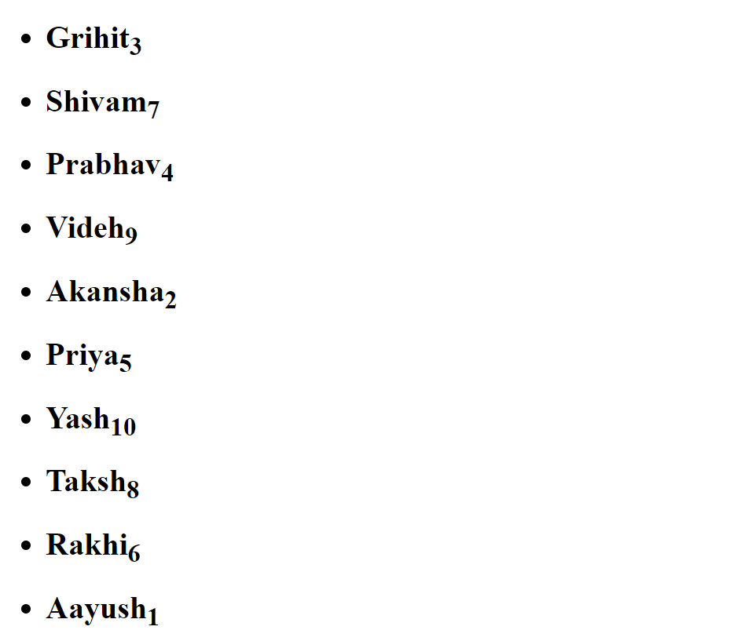

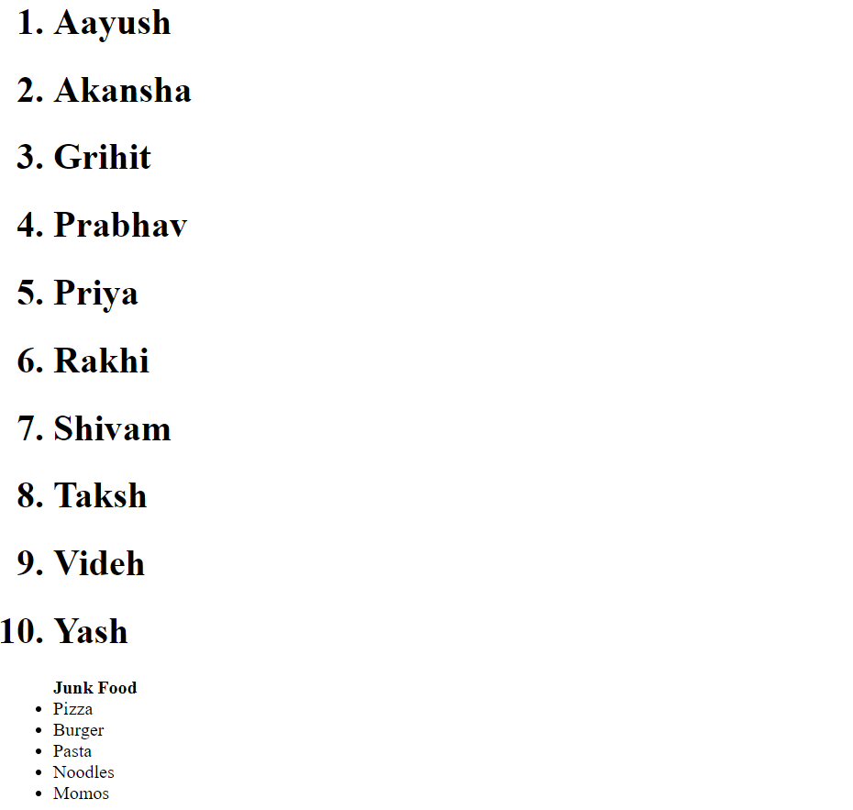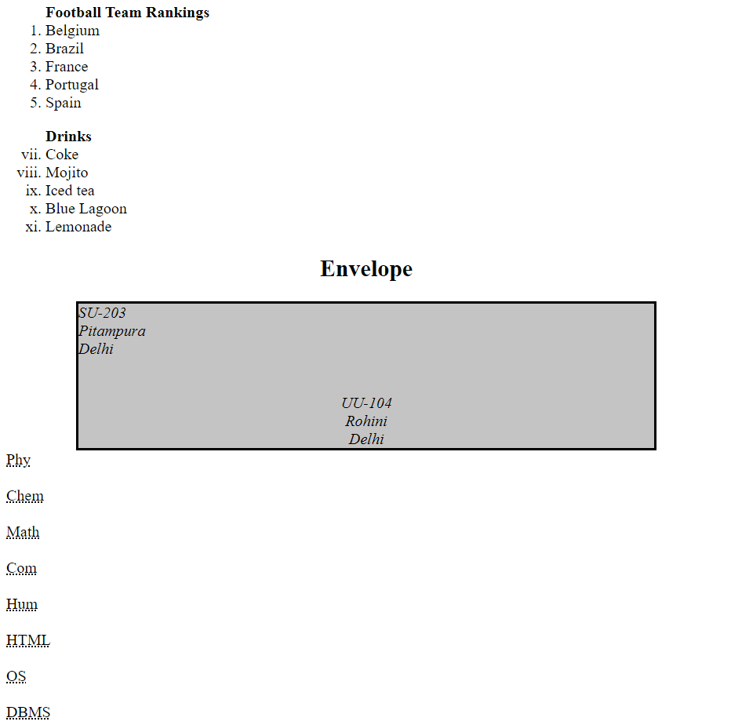

**Q4**

**Code –**

<!DOCTYPE html>

<html lang="en">

<head>

<meta charset="UTF-8">

<meta http-equiv="X-UA-Compatible" content="IE=edge">

<meta name="viewport" content="width=device-width, initial-scale=1.0">

<title>Document</title>

</head>

<body>

<table style="margin-left:auto;margin-right:auto;" border="3px">

<th colspan="4" >Purchased Equipments (June,2006)</th>

<tr>

<th rowspan="3">Item Num#:</th>

<tr>

<th rowspan="2">Item Picture</th>

<th >Item Description</th>

<th>Price</th>

</tr>

<tr>

<th>Shipping Handling, Installation, etc</th>

<th>Expense</th>

</tr>

<tr>

<td style="text-align: left;" rowspan="3">1.</td>

<tr>

<td rowspan="2"><img style="width:30%; align-self: center;" src="https://iconarchive.com/download/i47362/icons-land/vista-hardware-devices/Computer.ico"></td>

<td style="text-align: left;" >IBM Clone Computer</td>

<td style="text-align: left;">$ 400</td>

</tr>

<tr>

<td style="text-align: left;">Shipping Handling, Installation, etc</td>

<td style="text-align: left;">$ 200</td>

</tr>

<tr>

<td style="text-align: left;" rowspan="3">2.</td>

<tr>

<td rowspan="2"><img style="width:30%;" src="https://images.all-free-download.com/images/graphicthumb/ram_drive_100372.jpg"></td>

<td style="text-align: left;" >1 GB RAM Module for Computer</td>

<td style="text-align: left;">$ 50</td>

</tr>

<tr>

<td style="text-align: left;">Shipping Handling, Installation, etc</td>

<td style="text-align: left;">$ 14</td>

</tr>

<th colspan="4" style="text-align: center;" >Purchased Equipments (June,2006)</th>

</table>

</body>

</html>

**Output –**



**Q5.**

**Code –**

<!DOCTYPE html>

<html lang="en">

<head>

<meta charset="UTF-8">

<meta http-equiv="X-UA-Compatible" content="IE=edge">

<meta name="viewport" content="width=device-width, initial-scale=1.0">

<title>Q5</title>

</head>

<body style="padding: 10px;">

<div style="width: 500px; background-color: rgb(221, 221, 221); border: black; border-style: solid;">

<div style="background-color: rgb(168, 168, 168); text-align: right; padding: 5px 30px 5px 0px">

<b>The World of Fruit</b>

</div>

<div style="text-align: right; padding: 5px 100px 0px 20px;">

<b>Fruit Survey</b><br><br>

</div>

<form>

<div style="text-align: right; padding: 5px 100px 5px 20px;">

<label for="name">Name </label>

<input type="text" id="name" name="name"><br><br>

<label for="add">Address </label>

<input type="text" id="add" name="add"><br><br>

<label for="email">Email </label>

<input type="text" id="email" name="email"><br><br>

</div>

<div style="margin:0px 20px; ">

<label for="0">How many pieces of fruit do<br>you eat per day?&nbsp;&nbsp;&nbsp;&nbsp;&nbsp;&nbsp;&nbsp;&nbsp;&nbsp;&nbsp;&nbsp;&nbsp;&nbsp;&nbsp;&nbsp;&nbsp;&nbsp;&nbsp;&nbsp;&nbsp;&nbsp;&nbsp;&nbsp;&nbsp;</label>

<input type="radio" id="0" name="fruit" value="0">

<label for="0">0</label><br>

<div style="margin-left: 205px;">

<input type="radio" id="1" name="fruit" value="1">

<label for="1">1</label><br>

<input type="radio" id="2" name="fruit" value="2">

<label for="2">2</label><br>

<input type="radio" id="more" name="fruit" value="More than 2">

<label for="1">More than 2</label><br>

</div>

<br>

<span style="margin-left: 70px;">My favourite fruit</span><br>

<select name="fruit" id="fruit" size="4" style="margin-left: 205px;" >

<option value="Apple">Apple</option>

<option value="Banana">Banana</option>

<option value="Plum">Plum</option>

<option value="Pomegranate">Pomegranate</option>

<option value="Orange">Orange</option>

<option value="Kiwi">Kiwi</option>

</select>

</div>

<div style="margin-left: 70px;">

<label for="brochure">Would you like a <br>brochure?</label>

<div style="margin-left: 145px;">

<input type="checkbox" id="brochure"><br>

</div>

</div>

<br>

<div style="text-align: center; padding-bottom: 20px;">

<input type="submit">

</div>

</form>

</div>

</body>

</html>

**Output –**

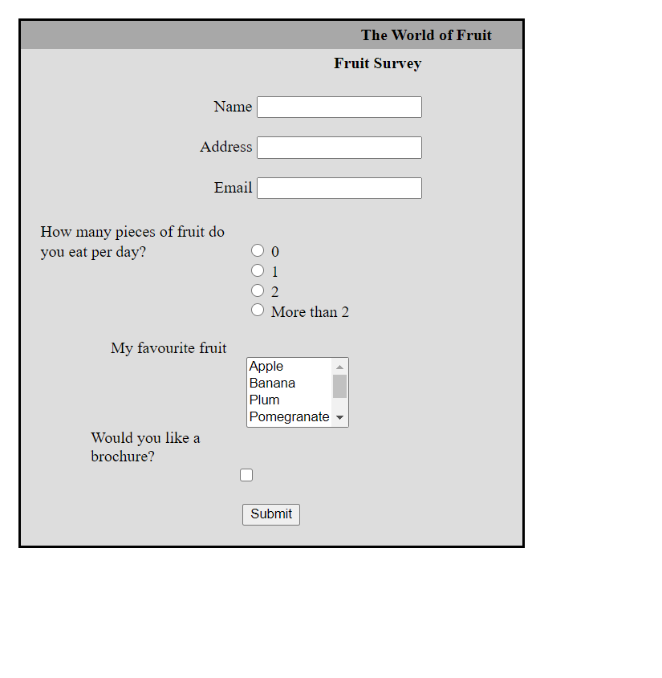

**Q6.**

**HTML Code –**

<!DOCTYPE html>

<html lang="en">

<head>

<meta charset="UTF-8">

<meta http-equiv="X-UA-Compatible" content="IE=edge">

<meta name="viewport" content="width=device-width, initial-scale=1.0">

<title>About Me</title>

<link rel="stylesheet" href="./q2.css">

</head>

<body>

<h2>Grihit Budhiraja</h2>

<h3>SU 203, Pitampura, Delhi </h3>

<p>I am a 2nd year Btech CSE student in VIT Vellore. I am from Delhi. I am interested <br> in <em><b>Competitive coding</b></em> and also like to play <em><b>football</b></em> in my spare time</p>

<table border="2"  >

<th ><h3>Classes I am taking this semester</h3></th>

<th ><h3>Description of each class</h3></th>

<tr>

<td>Internet and Web Programming</td>

<td>Information about detailed web programming and <br> various technologies used for making websites and web apps</td>

</tr>

<tr>

<td>Java programming</td>

<td>Information about detailed Java programming and <br> various algorithms used for making java applications and java apps</td>

</tr>

<tr>

<td>Software Engineering</td>

<td>Information about various steps involved in software <br> development and dellivery along with proper implementation.</td>

</tr>

<tr>

<td>Data Visualidation</td>

<td>Information about various data Visualisation techniques<br> and their application in real life</td>

</tr>

<tr>

<td>Numerical Ability and intelligence</td>

<td>Information about various questions asked during placement <br> interviews</td>

</tr>

<tr>

<td>Network and Communication</td>

<td>Information about Network and communication techniques<br> with various components of a common network and the internet.</td>

</tr>

</table>

<h4>My 3 favourite Movies</h4>

<ol type="1">

<li><a href="https://www.imdb.com/title/tt0266543/" target="_blank">Finding Nemo</a></li>

<li>Into the wild</li>

<li>The Lion King</li>

</ol>

<table>

<th>Image that makes me happy</th>

<th>Image that makes me sad</th>

<tr>

<td><img height="500" width="500" src="https://happyologist.co.uk/wp-content/uploads/happy.jpeg"></td>

<td><img height="500" width="500" src="https://thesayingquotes.com/wp-content/uploads/2019/02/sad-quotes.jpg"></td>

</tr>

</table>

<h4>Something about my neighbour</h4>

<p>He is a very short tempered guy but can also be sweet sometimes. <br>He always used to call us over for dinner but ever since <br> the pandemic, we haven't been meeting much. I am good <br> friends with his son who is about the same age as me.</p>

<h4>My skill level in programming languages</h4>

<table>

<th> Coding Language </th>

<th >Skill Level</th>

<tr>

<td>C++</td>

<td>8/10</td>

</tr>

<tr>

<td>Python</td>

<td>7/10</td>

</tr>

<tr>

<td>JavaScript</td>

<td>6/10</td>

</tr>

<tr>

<td>Java</td>

<td>4/10</td>

</tr>

</table>

</body>

</html>

**CSS Code –**

body{

    background-color: aliceblue;

    text-align: center;

    border: thick;

    border-style: solid;

}

td{

    color: red;

    font-size: medium;

    font-family: 'Courier New', Courier, monospace;

    font-weight: bold;

    font-style: oblique;

}

li{

    color: green;

    font-size: large;

    font-family: 'Franklin Gothic Medium', 'Arial Narrow', Arial, sans-serif;

    font-weight: 500;

    font-style: italic;

}

ol{

    text-align: left;

}

**Output –**

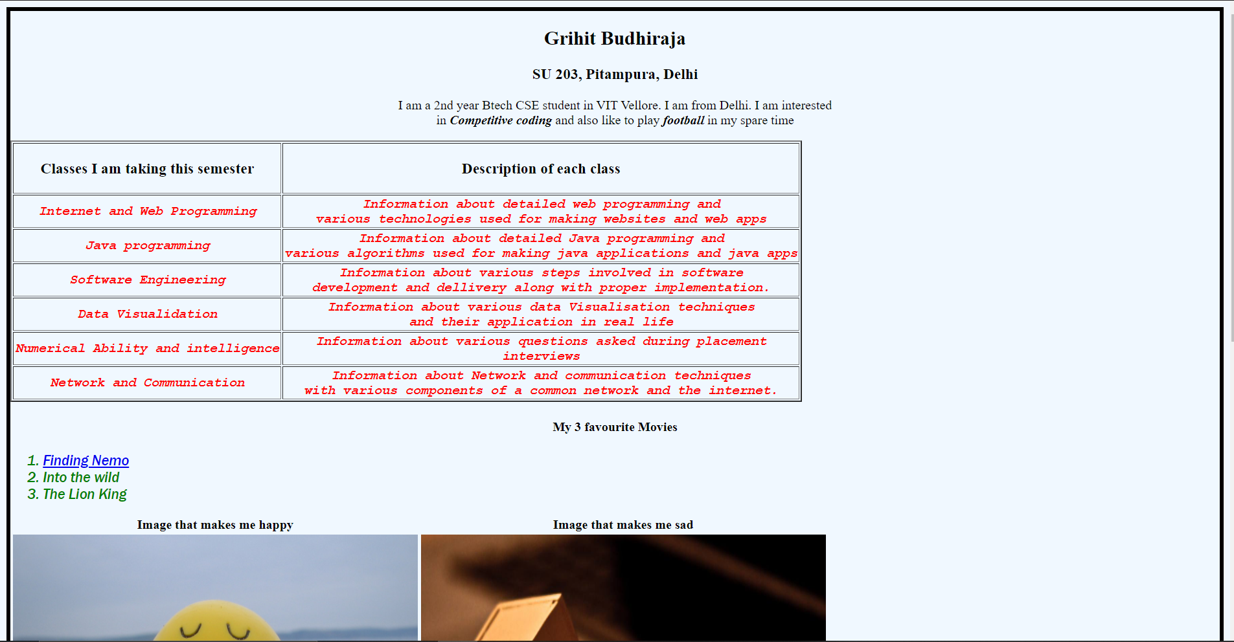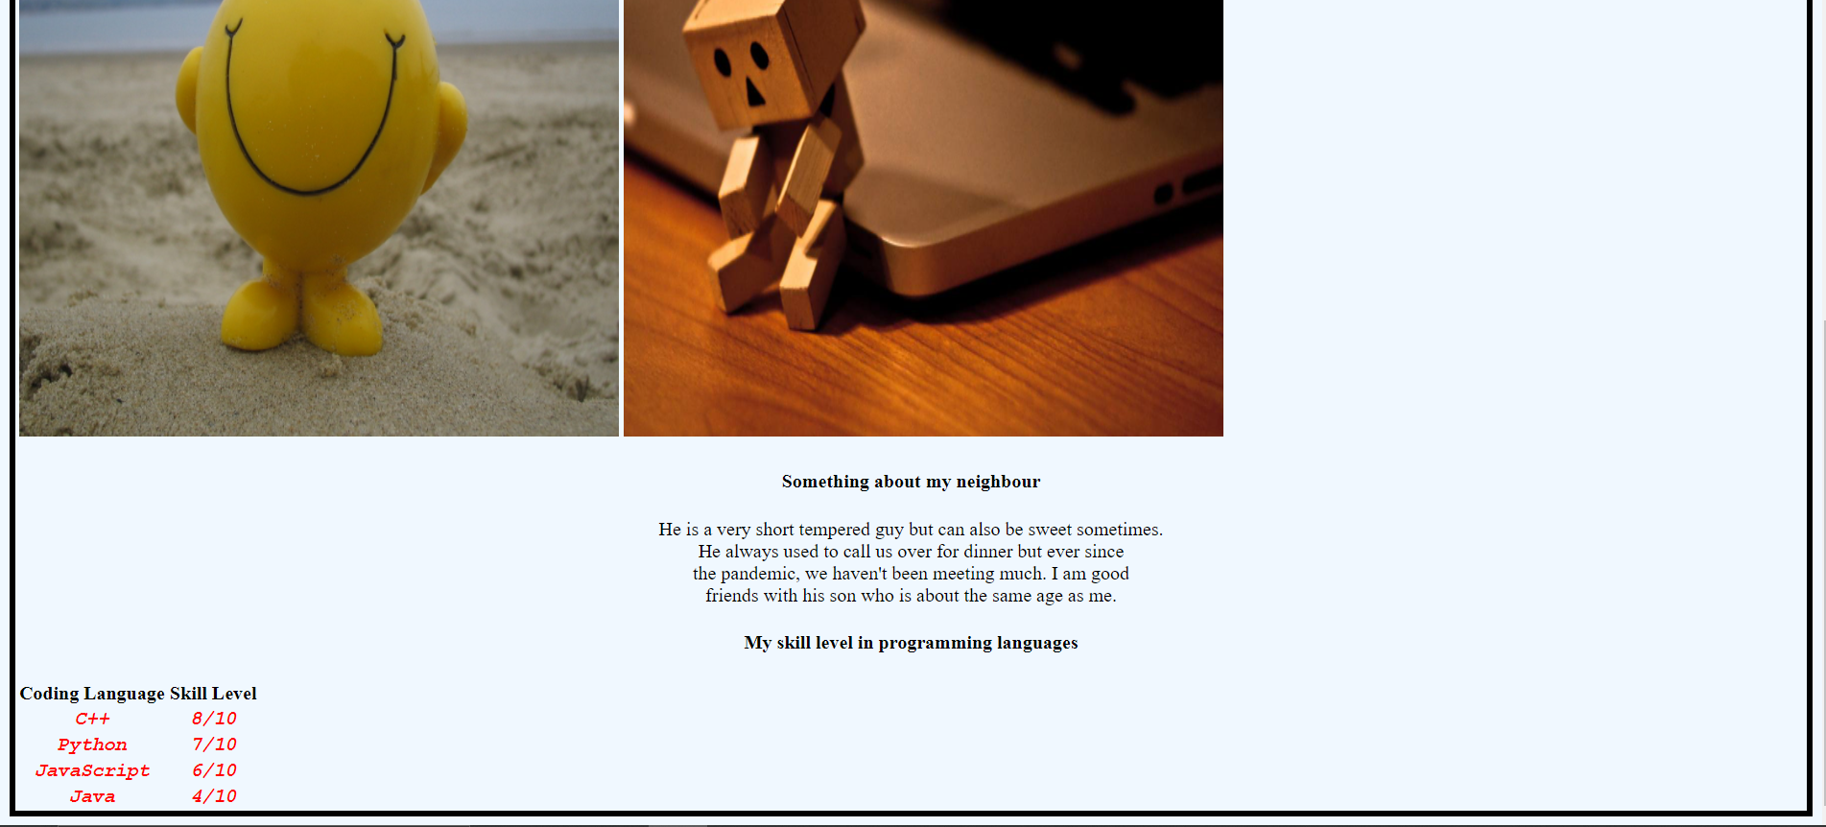

**Q7.**

**HTML Code –**

<!DOCTYPE html>

<html lang="en">

<head>

<meta charset="UTF-8">

<meta http-equiv="X-UA-Compatible" content="IE=edge">

<meta name="viewport" content="width=device-width, initial-scale=1.0">

<title>Wall E</title>

<link rel="stylesheet" href="./q7.css">

</head>

<body>

    <div class="white_box">

        <h2>WALL-E</h2>

        <b>Walt Disney Studio Motion Picture | Release date Jun 27,2008</b>

        <br><br><br>

        <div class="menu">

            <span class="items">Summary</span>

            <span class="items">Critic Reviews</span>

            <span class="items">User Reviews</span>

            <span class="items">Details and Credits</span>

            <span class="items">Trailers and Videos</span>

        </div>

        <br>

        <div class="desc">

            <img src="https://noma.org/wp-content/uploads/2016/08/WALLE.jpg" alt="Wall-E Cover" width="75px" height="150px">

            <div class="rating"><br><span class="value">94</span></div>

            <div class="score">

                <br>

                <span class="meta"><b>Metascore</b></span>

                <br><br><br>

                <span>Universal acclaim<br>

                based on 39 critics</span>

                <br>

                <ul>

                    <li>Starring Ben Elliot, Elissa Knight,Jeff Gerlin</li>

                    <li>Summary: After hundreds of lonely years of doing what he <br>was bulit for, Wall-E discovers a new purpose in life when <br>he meets a sleek search robot name EVE[Walt Disney <br>Pictures]</li>

                </ul>

            </div>

        </div>

    </div>

</body>

</html>

**CSS Code –**

body{

    background-color: gray;

}

div.white_box{

    width: 80%;

    margin: auto;

    background-color: white;

    padding: 20px;

border: solid black thin;

}

h2{

    text-align: center;

}

span.items{

    background-color: black;

    color: white;

    padding: 0 20px;

    margin-right: 3px;

}

img{

    display: inline;

}

div.desc{

    display: table;

    overflow: auto;

}

div.rating{

    display: table-cell;

    vertical-align: top;

    color: white;

    border: solid white 5px;

    overflow: hidden;

}

span.value{

    background-color: green;

    font-size: 30pt;

    padding: 20px;

}

div.score{

    display: table-cell;

    vertical-align: top;

}

span.meta{

    font-size: 18pt;

}

**Output –**

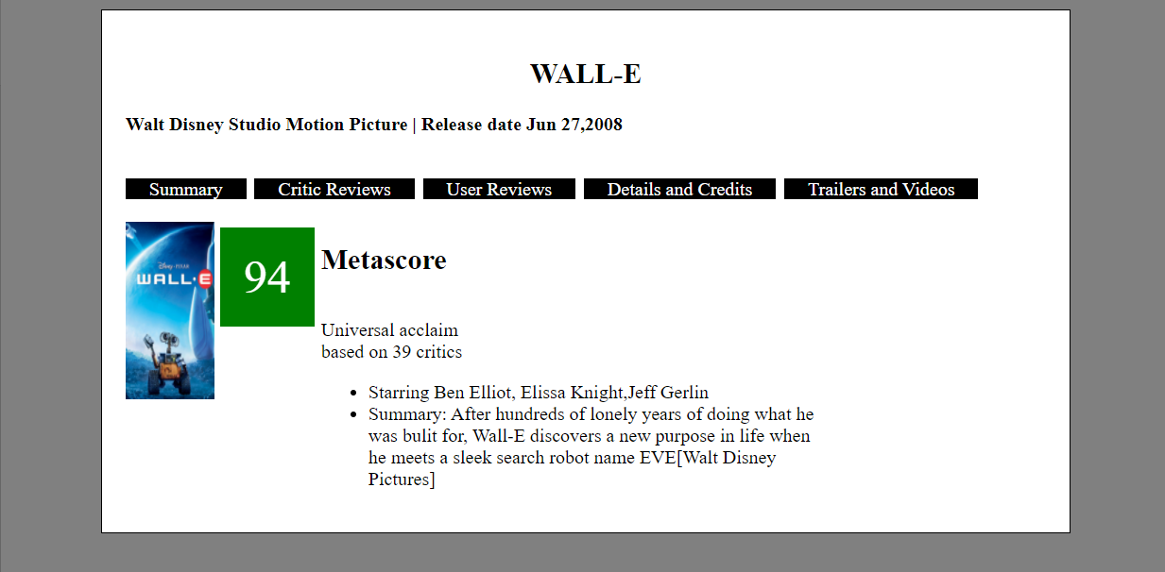

**Q8.**

**CSS Code –**

div.outer{

    border: solid black thin;

}

div.top{

    position: relative;

    border: solid black thin;

    margin: 8px;

    overflow: hidden;

}

img{

    position: absolute;

    opacity: 0.7;

    z-index: 1;

    width: 100%;

}

p.title{

    position: relative;

    z-index: 2;

    margin: 50px 8px;

    font-size: 25pt;

    font-weight: bolder;

}

div.flex-container{

    display: flex;

}

div.navigation{

    border: solid black thin;

    margin: 0px 8px 8px 8px;

    padding: 8px;

    width: 50%;

    background-color: lightyellow;

}

div.navigation a{

    font-size: large;

}

div.content{

    border: solid black thin;

    margin: 0px 8px 8px 0px;

    padding: 8px;

}

a:hover{

    color: red;

    font-weight: bold;

}

**Example HTML Code –**

<!DOCTYPE html>

<html lang="en">

<head>

<meta charset="UTF-8">

<meta http-equiv="X-UA-Compatible" content="IE=edge">

<meta name="viewport" content="width=device-width, initial-scale=1.0">

<title>Presentation</title>

<link rel="stylesheet" href="./q8.css">

</head>

<body>

    <div class="outer">

        <div class="top">

            <img src="https://i.pinimg.com/originals/e8/c7/c4/e8c7c4d4e14a9e3b21faf3d7b37c5b03.jpg" alt="Background image">

            <p class="title">Title Text</p>

        </div>

        <div class="flex-container">

            <div class="navigation">

                <a href="www.facebook.com">Facebook</a><br>

                <a href="www.google.com">Google</a><br>

                <a href="www.twitter.com">Twitter</a><br>

            </div>

            <div class="content">

                <p><a href="https://en.wikipedia.org/wiki/Main_Page">Wikipedia</a> is a free, multilingual open-collaborative <a href="https://en.wikipedia.org/wiki/Online_encyclopedia">online encyclopedia</a> created and maintained by a community of volunteer contributors using a wiki-based editing system. Wikipedia is the largest general reference work on the Internet, and one of the 15 most popular websites as ranked by <a href="https://en.wikipedia.org/wiki/Alexa_Internet">Alexa</a>; in 2021, it was ranked as the 13th most visited. The project carries no advertisements and is hosted by the <a href="https://en.wikipedia.org/wiki/Wikimedia_Foundation">Wikimedia Foundation</a>, an American non-profit organization funded mainly through donations, 80% of which are small donations from individual users.</p>

            </div>

        </div>

    </div>

</body>

</html>

**Output –**

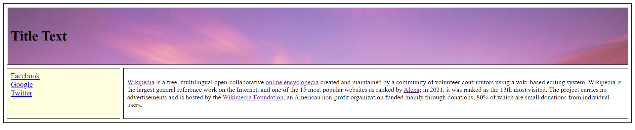

**Q9.**

**HTML Code –**

<!DOCTYPE html>

<html lang="en">

<head>

<meta charset="UTF-8">

<meta http-equiv="X-UA-Compatible" content="IE=edge">

<meta name="viewport" content="width=device-width, initial-scale=1.0">

<title>Multimedia</title>

</head>

<body>

    <h3>2 Sample Images</h3><br>

    <img src="./multimedia/1.jpg" alt="image 1" width="500px" height="500px">

    <img src="./multimedia/2.jpg" alt="image 2" width="500px" height="500px">

    <br><h3>1 Sample Video</h3><br>

    <video width="500" height="500" autoplay muted>

        <source src="./multimedia/3.mp4" type="video/mp4">

    </video>

</body>

</html>

**Output –**

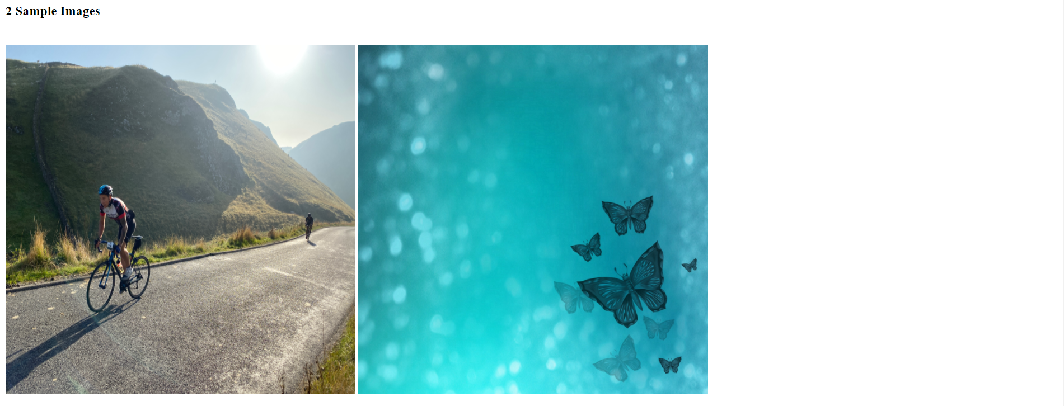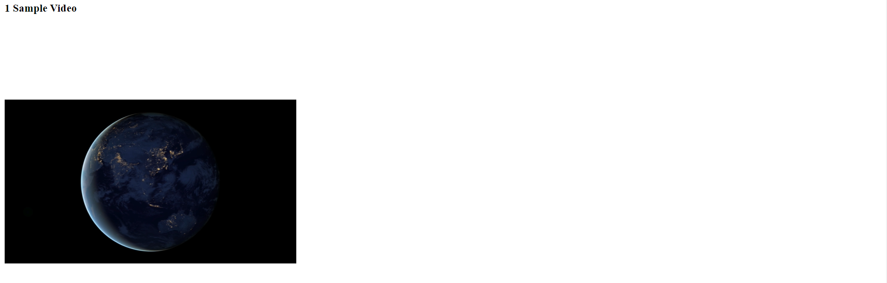

**Q10.**

**HTML Code –**

<!DOCTYPE html>

<html lang="en">

<head>

<meta charset="UTF-8">

<meta http-equiv="X-UA-Compatible" content="IE=edge">

<meta name="viewport" content="width=device-width, initial-scale=1.0">

<title>Newspaper</title>

<link rel="stylesheet" href="./q10.css">

</head>

<body>

    <p class="top-heading">Self Contol is the key to success</p>

    <p class="bottom-heading">If you are able to achieve self control, you have won half the battle...</p>

    <div class="newspaper">

        <span class="first">L</span>orem ipsum dolor sit amet, consectetur adipiscing elit. Sed placerat feugiat condimentum. Pellentesque ultricies luctus mauris, quis dapibus libero rutrum sit amet. Phasellus rhoncus finibus ultrices. Pellentesque quis dui at mauris commodo sollicitudin. Vestibulum nec urna placerat eros posuere pretium at eu nunc. In sed urna mi. Aenean id enim ante. Nam ullamcorper nisi justo, a dapibus arcu interdum faucibus. Morbi tincidunt odio dui, sed ullamcorper orci mollis non. Pellentesque euismod viverra facilisis.

        Pellentesque at nisl elit. Donec lobortis, elit sed convallis elementum, risus diam ultricies lacus, non pellentesque neque dui eget ante. Pellentesque commodo ultrices dolor. Maecenas sodales velit a ligula mattis, dictum pharetra est sagittis. Nam rhoncus et nisi sit amet feugiat. Fusce imperdiet velit sed fermentum ultricies. Donec nec facilisis nisl. Curabitur nec mauris in lacus sodales cursus a eu nisi. Vestibulum ornare faucibus venenatis. Ut vulputate sit amet sapien eget fringilla. Phasellus sollicitudin tincidunt neque, non dignissim purus aliquam eget.

        Suspendisse auctor diam at maximus cursus. Curabitur finibus nulla nec suscipit finibus. Nulla molestie, erat at luctus bibendum, magna nisi lobortis nulla, a imperdiet lectus dolor in arcu. Sed aliquet, odio quis sagittis tristique, nisl dui efficitur nunc, vitae consequat lacus lectus eu purus. Fusce sit amet tortor aliquam magna porttitor condimentum molestie in tortor. Duis mollis nunc odio, a tincidunt leo feugiat eget. Curabitur iaculis imperdiet velit ac volutpat. Donec facilisis enim quis dui dapibus tempor. Cras eu sem ut risus placerat venenatis vel ac nisi. Morbi iaculis mauris in ipsum vulputate tempus. Lorem ipsum dolor sit amet, consectetur adipiscing elit. Vestibulum ante ipsum primis in faucibus orci luctus et ultrices posuere cubilia curae; Maecenas at justo quis sem vestibulum elementum. In <div class="image"><img src="https://images.pexels.com/photos/358238/pexels-photo-358238.jpeg?auto=compress&cs=tinysrgb&dpr=1&w=500" alt="Image"><br><span>A BEAUTIFUL SCENERY</span></div>venenatis suscipit vehicula. Interdum et malesuada fames ac ante ipsum primis in faucibus. Nunc at laoreet lacus.

        Aenean dapibus, nibh ut fermentum fermentum, orci neque maximus erat, id pretium risus urna at quam. Vivamus tempus nisl vitae tellus bibendum lacinia. Curabitur eget pharetra lectus. Mauris vulputate pharetra quam, eget scelerisque elit facilisis ac. Vivamus quis finibus turpis. Etiam elementum varius dolor, sit amet vulputate arcu tristique ac. Aliquam non tellus felis. Fusce non odio non dolor lobortis aliquet at nec mauris. Morbi ut orci rutrum, lacinia orci ac, placerat urna. Donec convallis magna ac purus consequat cursus. Duis in dictum nibh. Pellentesque non sodales neque. Proin id fermentum nisl.

        Ut lectus nibh, tempor vel sapien id, ornare suscipit tortor. Aliquam vitae ullamcorper tortor, in volutpat est. Donec et tortor nunc. Aenean at lacus ut ipsum placerat interdum. Quisque et sodales arcu. Sed pulvinar, ante id tempus molestie, felis dui rutrum lectus, sed porta quam lacus quis elit. Quisque dignissim malesuada consectetur. Curabitur efficitur et lectus sit amet tincidunt. Cras id erat ornare, tincidunt massa in, porttitor dolor. Curabitur ut nunc vitae eros condimentum commodo. Proin nibh magna, vestibulum quis ex in, congue rhoncus est. Duis eget pulvinar nisi. Phasellus at diam posuere, tincidunt arcu sed, cursus ligula. Ut in enim nunc.

        Nam sodales erat metus, non maximus mauris fermentum eu. Etiam id velit scelerisque, aliquet arcu quis, ultricies metus. Cras in lobortis felis. Maecenas dignissim arcu non consequat tempus. Lorem ipsum dolor sit amet, consectetur adipiscing elit. Phasellus feugiat fringilla rhoncus. Sed id augue at est egestas bibendum et id massa.

        viverra, enim vitae elementum fermentum, nulla nisl feugiat diam, vel blandit tortor ipsum eget erat. Cras vitae semper neque, nec lobortis velit. Suspendisse sit amet nibh metus. Nam odio ligula, porttitor nec odio id, interdum interdum enim. Integer hendrerit erat neque, et euismod quam sollicitudin laoreet. Vestibulum rhoncus, magna id consectetur ornare, diam mauris convallis diam, in ultrices eros sem et orci. Lorem ipsum dolor sit amet, consectetur adipiscing elit.

        Pellentesque et varius <div class="blue-box">Lorem ipsum dolor sit amet, consectetur adipiscing elit. Sed placerat feugiat condimentum. Pellentesque ultricies luctus mauris, quis dapibus libero rutrum sit amet. Phasellus rhoncus finibus ultrices. Pellentesque quis dui at mauris commodo sollicitudin.</div>neque. Morbi ut placerat turpis. Donec vel ante mattis, accumsan justo in, condimentum massa. Nullam id augue molestie, condimentum purus in, gravida urna. Cras dapibus nec arcu vitae ultricies. Aliquam eget erat ornare, consectetur est vitae, aliquam arcu. Curabitur fermentum egestas risus, nec blandit justo ultrices at. Interdum et malesuada fames ac ante ipsum primis in faucibus. Sed dictum turpis eget lacinia aliquet. Cras id risus nisi. Aenean tristique, sapien sit amet eleifend viverra, purus quam tempor risus, vehicula cursus dui mauris vel elit. Vivamus congue, ex convallis rutrum cursus, leo est vehicula nunc, quis porta mi elit in est. Duis porta diam lorem, non hendrerit massa blandit eget.

        Nunc sagittis non quam sit amet eleifend. Quisque sed orci ut eros lobortis tempus a consectetur elit. Nulla molestie blandit magna non aliquam. In id volutpat massa, vel tempor purus. Maecenas tempor ex sed enim elementum sollicitudin. Curabitur imperdiet pharetra pretium. Nulla fringilla ultrices nibh eu aliquet. Maecenas mollis nec ligula euismod facilisis.

        Nunc eget tortor pulvinar, ultrices elit et, commodo nulla. Orci varius natoque penatibus et magnis dis parturient montes, nascetur ridiculus mus. In non feugiat odio. Aliquam sit amet orci risus. Donec id suscipit nisl, in bibendum enim. Ut ac viverra leo. Ut ac tempus purus. Vivamus in risus vestibulum, pharetra elit a, porttitor sapien. Phasellus ut convallis libero, molestie vulputate dolor.

    </div>

</body>

</html>

**CSS Code –**

p.top-heading{

    font-size: 50pt;

    margin: 10px;

    font-weight: 900;

}

p.bottom-heading{

    font-size: 20pt;

    margin: 10px;

    font-weight: 600;

}

div.newspaper{

    column-count: 4;

    text-align: justify;

}

span.first{

    font-size: 60pt;

    float: left;

}

div.image{

    border: solid black thin;

    background-color: red;

    text-align: center;

}

img{

    width: 100%;

}

div.image span{

    font-size: 20pt;

    color: white;

    font-weight: 800;

}

div.blue-box{

    background-color: lightblue;

    border: solid rgba(126, 201, 226, 0.555);

    font-weight: bold;

}

**Output –**

